# Bar Chart

## Found At:

<http://richhildebrand.github.io/Jason-Kipnis/barGraph.html>



## Adjust Graphed Data:

#### Add Bars to Graph

Add new bar graphs by clicking in the empty area of the multi select box.

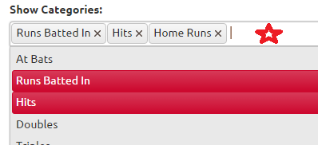

#### Remove Bars from Graph

Remove bars from graph by clicking the X on items in the multi select box.

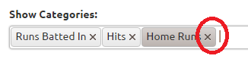

## Adjust the Data Grouping:

Choose the grouping for the data.

## 